Practical Analytical 1 Chemistry

Experimental 5:
Corrosion of Iron

*Chemicals and tools:

- Four Flasks
- Nails
- Water
- Pre-boiled water
- Salt water
- Drying agent (CaCl₂)

Procedure:
- Put the first nail in Flask 1 containing aerated water
- Put the second nail in Flask 2 containing drying agent without water and close it firmly
- Put the third nail in Flask 3 containing deaerated tap OR distilled water (Pre-boiling water) and close it firmly
- Put the nail in Flask 4 containing aerated salty water and close it firmly
- Leave all Flasks for one week and record your observations.

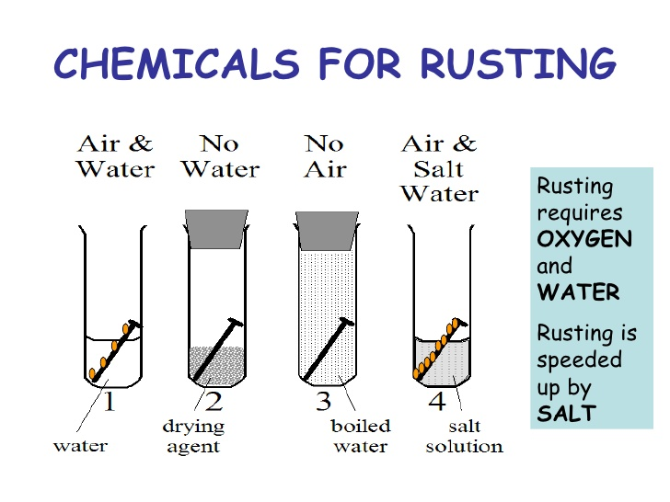
Results

1-Air + Water (aerated tap OR distilled water)

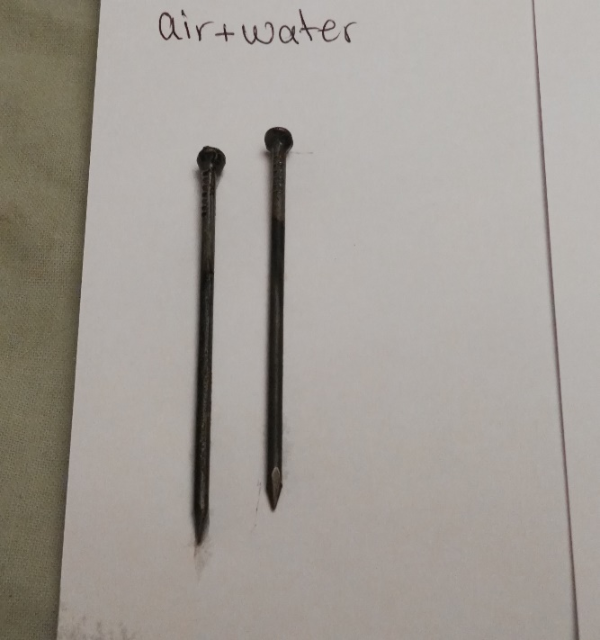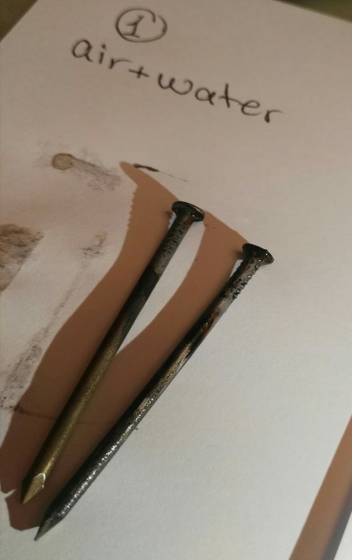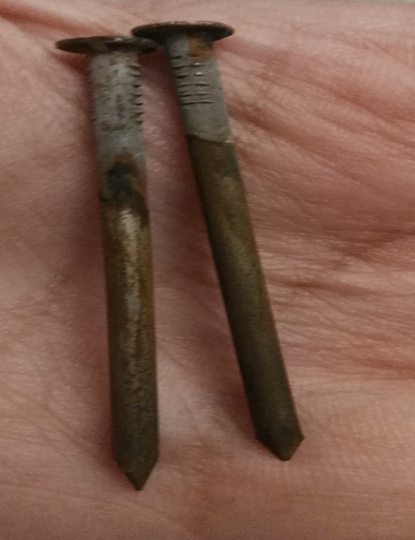

2-Dry agent (CaCl₂ powder)

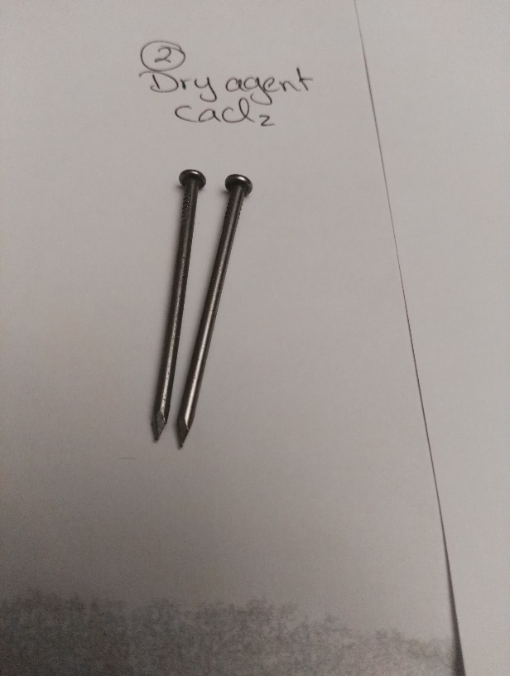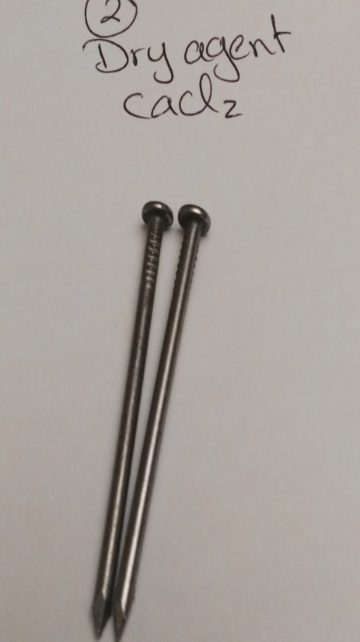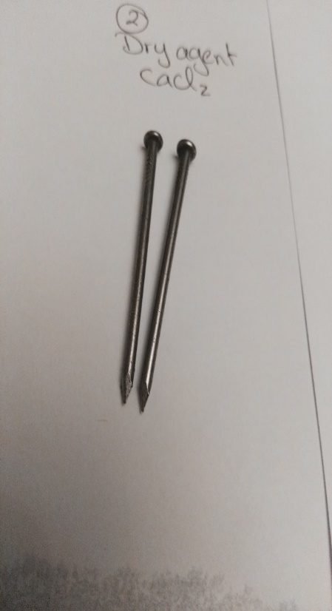

3-Pre boiling tap OR distilled water (Deaerated water)
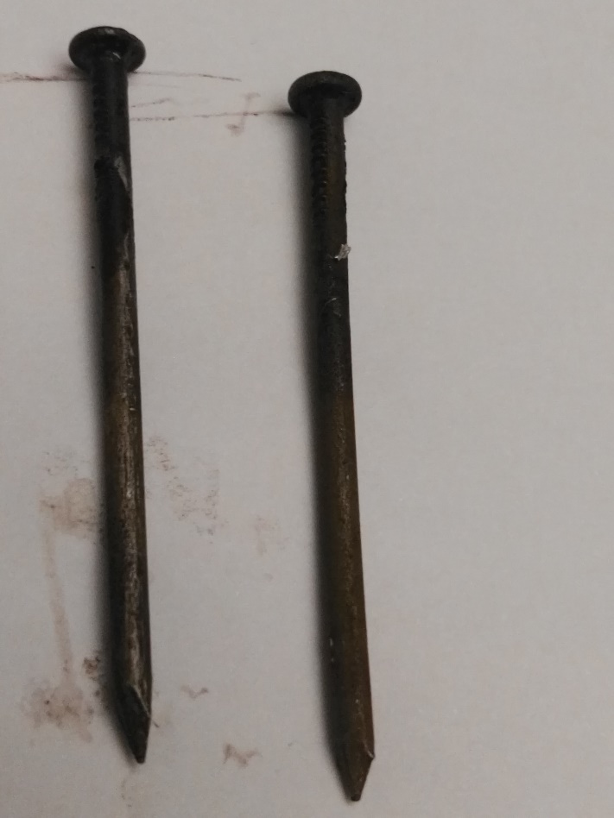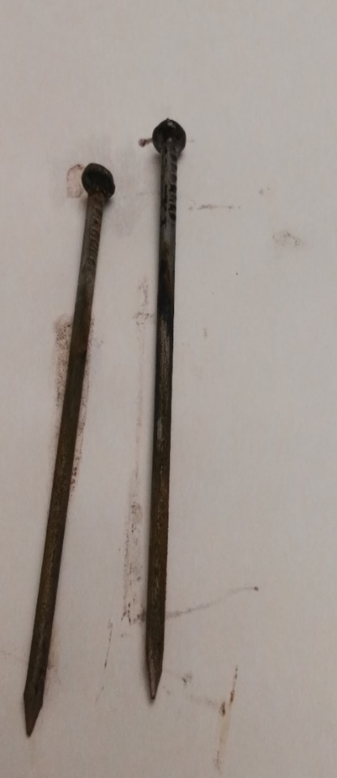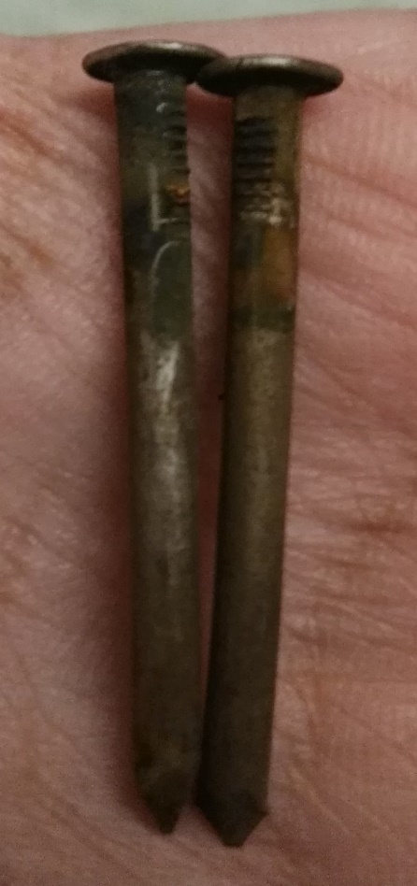

4-Aerated salty water
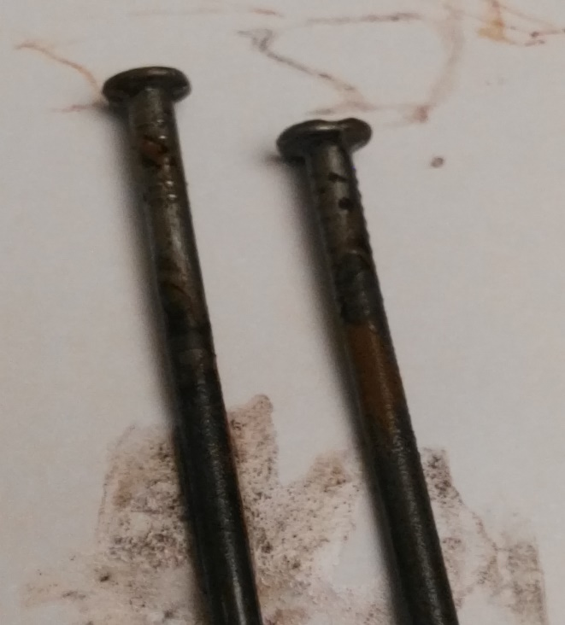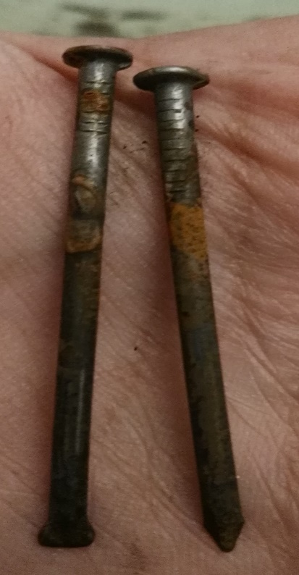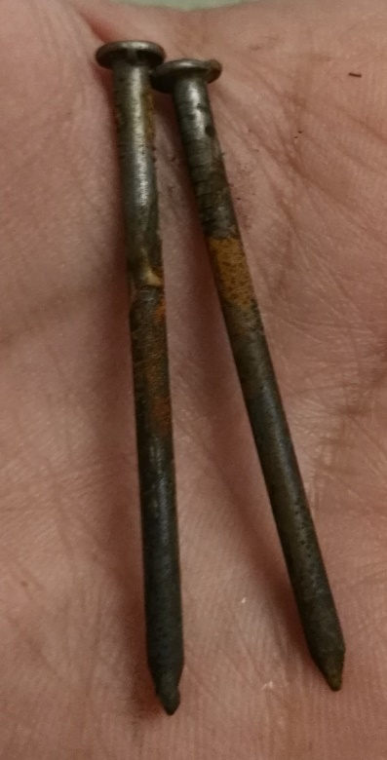

Comparison between the 4 flasks
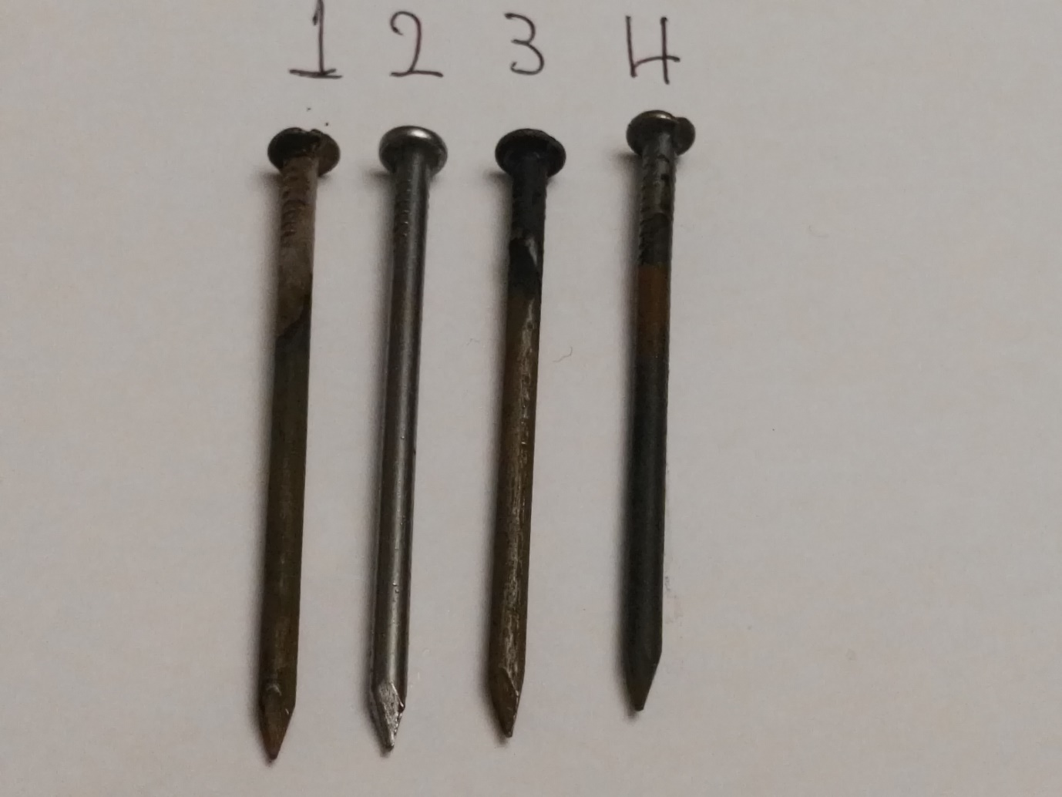
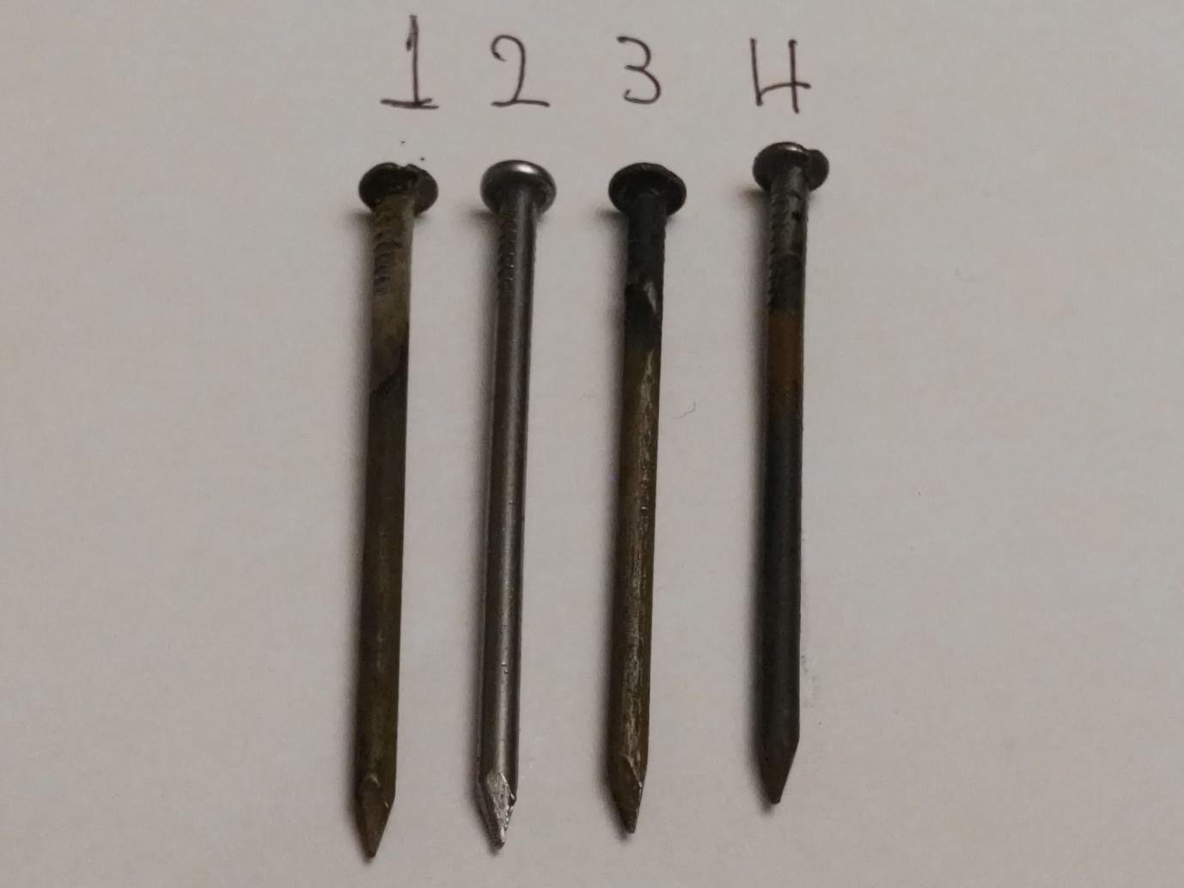
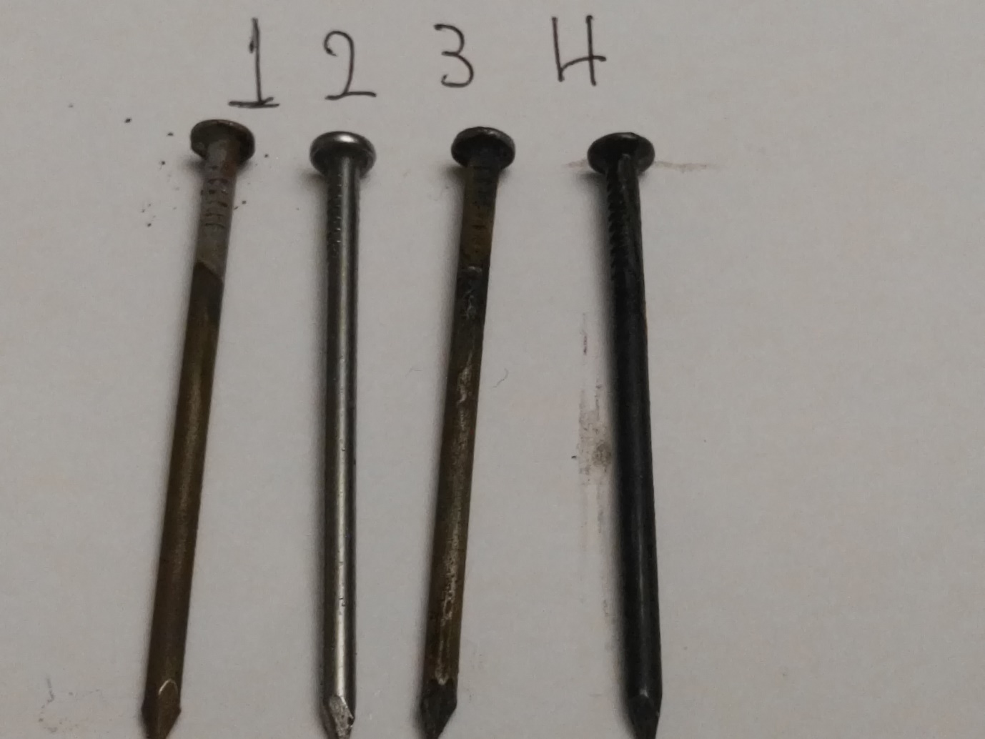

Conclusions

- Rusting is destruction of a metal due to the contact with its surrounding environment.
- Electrochemical corrosion takes place at the anodes of the micro cells formed on metal surface.
- The most corrosive environment are:
  - Air (moist and humid, hot, polluted),
  - Water (hot, salty, polluted).
- The nail in the dry air (Flask 2) does not corroded.
- The nail in the aerated salty water (Flask 4) is the most corroded one.
- The corrosion rate increases in the order:
- (Flask 2) < (Flask 3) < (Flask 1) < (Flask 4)
Dry air | < deaerated water | < aerated water | < aerated salty water

